Doxey Primary School
Calculation policy for multiplication and division
This calculation policy has been written alongside the long term plan for Maths in school, which is taken from the White Rose Maths Schemes of Learning.
This policy is written to enable children to become fluent mathematicians; being able to work flexibly, accurately and efficiently. It is expected that children move forwards/backwards between concrete, pictorial and abstract; often using different representations alongside each other in order to embed their conceptual understanding.
More details around the teaching and learning of each operation have been downloaded from the NCETM website. These documents are the NCETM Spines; 1 – addition and subtraction, 2 – multiplication and division and 3 – fractions, which can be found on Sharepoint.

Year guidance for multiplication | EYFS/Year 1  Recognising and making equal groups  Doubling numbers to 10 (1 to 10 inclusive)  Counting in multiples using cubes and other objects in the classroom | Year 2  Redistributing to make equal groups  Arrays – showing commutative multiplicaton  Doubling (known facts to 100 - Multiples of 5) | Year 3  Arrays  2 digit x 1 digit - Grid method  using place value counters or base 10  Doubling within 1,000 | Year 4  Column multiplication – introduced with place value counters  (2 and 3 digit multiplied by 1 digit)  Doubling numbers beyond 1,000 | Year 5  Column multiplication  Mainly abstract but might need a repeat of year 4 first (up to 4 digit numbers multiplied by 1 or 2 digit numbers) | Year 6  Column multiplication  Abstract methods (multi digit up to 4 digit numbers multiplied by a 2 digit numbers)
Year guidance for division | Sharing objects into groups.  Division as grouping e.g. I have 12 sweets and put them in groups of 3, how many groups?  Halving even numbers up to 20 | Division as grouping  Division as sharing  Division within arrays – linking to multiplication | Division with remainder – using times tables facts  2 digit divided by 1 digit using place value counters or base 10 | Division with remainder  Short division (up to 3 digits by 1 digits – concrete and pictorial) | Short division  (up to 4 digits by 1 digit number – including remainders) | Short division  Long division with place value counters (up to 4 digits by a 2 digit remainder)  Children should exchange into the tenths and hundredths column too.

Objective and strategy | Concrete | Pictorial | Abstract
Multiplication  Making equal groups  Ensure children can identify unequal groups and redistribute to make them equal. | 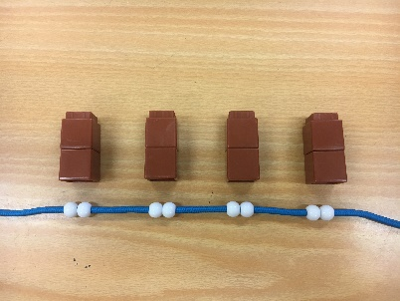  Use manipulatives to create equal groups | 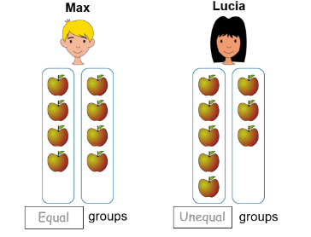  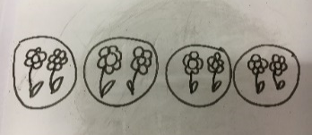  Draw and make representations to show equal groupings | 2 + 2 + 2 + 2
Multiplication  Repeated grouping/ repeated addition | 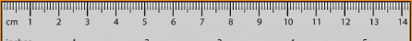  2 x 4 | Represent this pictorially alongside a bar model  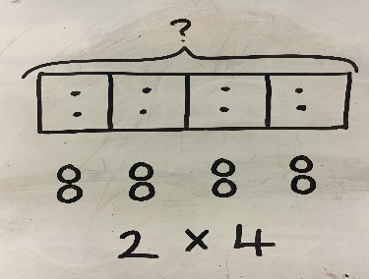 | Abstract number line showing 4 jumps of 2  2 x 4  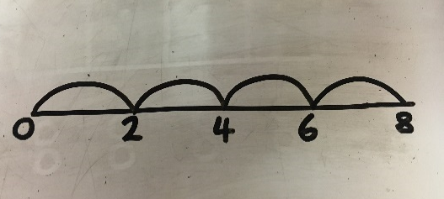
Multiplication  Use arrays to illustrate commutativity | – multi link and other objects can also be used  2 x 4 = 4 x 2  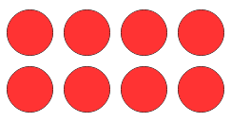  2 lots of 4 4 lots of 2 | Children to represent the arrays pictorially  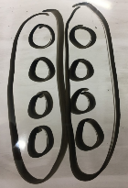  2 lots of 4 4 lots of 2 | Children to be able to use an array to write a range of calculations  8 = 2 x 4  8 = 4 x 2  2 x 4 = 8  4 x 2 = 8
Division  Dividing as grouping  Dividing as sharing | Grouping using a range of objects  8 $÷$ 2  8 grouped into 2s  There are 4 groups of 2 in 8  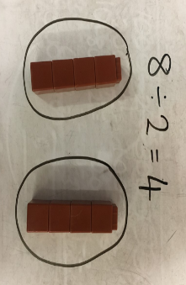  8 $÷$ 2  8 shared between 2 | Represent the grouping pictorially  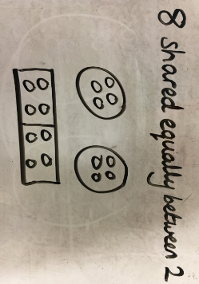  Children should also be encouraged to use their 2 times tables facts | 8 $÷$ 2 = 4
Multiplication  Grid method | Show the links with arrays to first introduce the grid method 3 x 14 =  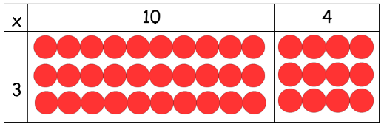  3 rows of 10 and 3 rows of 4  Move onto base ten to move towards a more compact method.  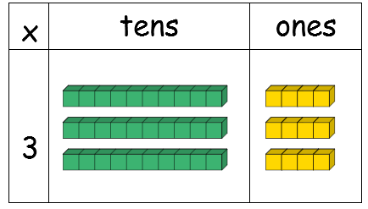  3 x 14 =  3 rows of 14  Encouraging children to count in multiples to multiply more effeciently. | 3 x 14 =  Partition the 2 digit number into tens and ones.  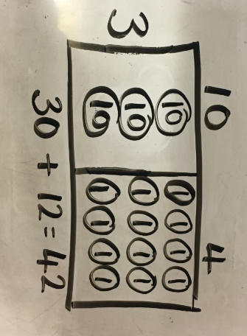  3 x 10 = 30 3 x 4 = 12 43 + 12 = 42 | 3 x 14 =  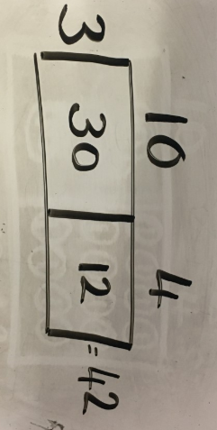
Division  Grouping leading to short division  no remainders | 42 ÷ 3 = 14  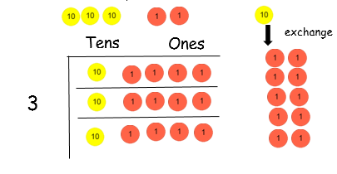  We are grouping in 3s so we need 3 rows  Use place value counters alongside short division method | Children to represpent the place value counters pictorially.  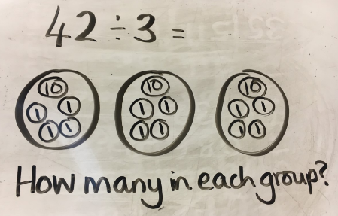  Encourage chidlren to count in multiples to divide more efficiently | 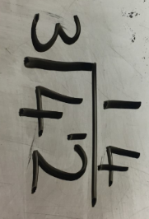  1 ten in each group with 1 ten remaining.  Exchange that 10 for ten ones so the 2 ones now become 12 ones.  4 ones in each group.  In total there is 1 ten and 4 ones in each group.
Division  Sharing leading to short division  no remainders | Using place value counters 42 ÷ 3 = 14  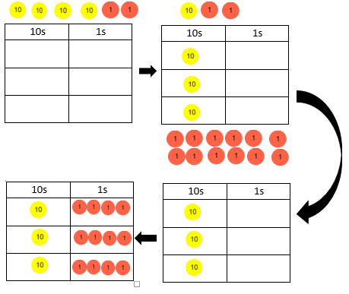 | Children to represpent the place value counters pictorially  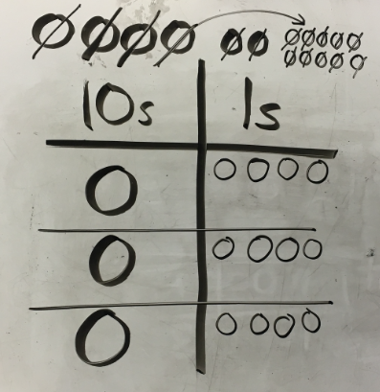 | Children to be able to make sense of the place value counters and write calculations to show the process  42 ÷ 3  42 = 30 + 12  30 ÷ 3 = 10  12 ÷ 3 = 4  10 + 4 = 14  Start to include remainders
Multiply two and three digit numbers by 1 digit  Moving into column multiplication compact method | 126 x 4 =  We are multiplying by 4 so we need 4 rows  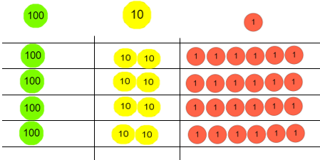  Fill each row with 126  Add up each column starting with the ones making any exchanges needed  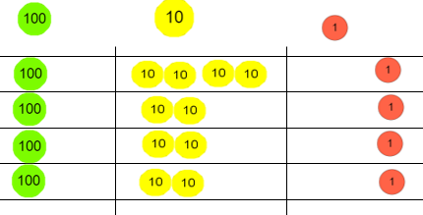  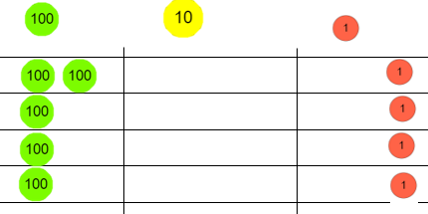  Then you have your answer  126 x 4 = 504 | Children to represpent the place value counters pictorially  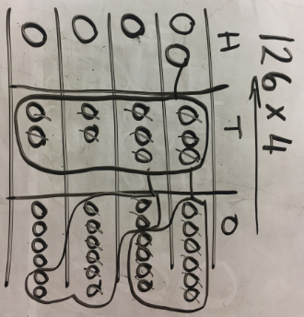  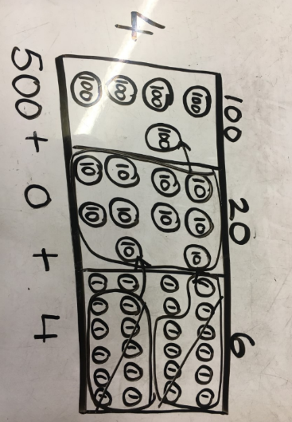 | 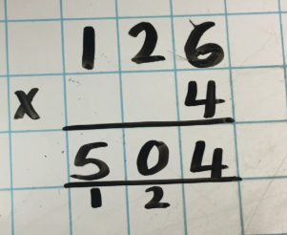  When children have understood the concept they should be able to use compact method. Initially this will need to be alongside concrete or pictorial.
Divide two and three digit numbers by 1 digit.  Moving into short division with remainders |  | Use mental strategies alongside jottings  615 ÷ 5 =  15 ÷ 5 = 3  500 ÷ 5 = 100  100 ÷ 5 = 20  100 + 20 + 3 = 123 | 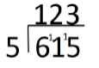  Begin with divisions that divide equally with no remainders  Move onto divisions with remainders
Multiply two digit numbers by two digit numbers  Progressing to multiplying larger numbers by two digits. | Manipulatives may still be used with the corresponding long multiplication modelled alongside. | 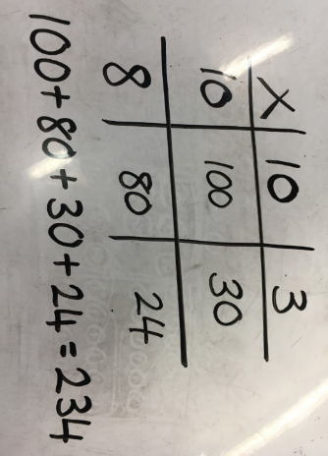  Using the grid method | 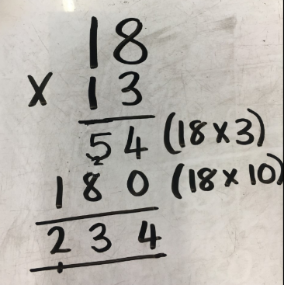  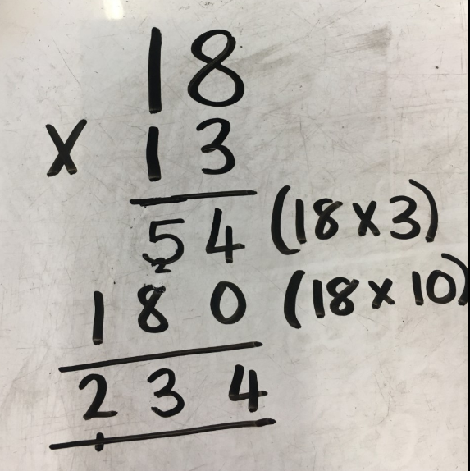  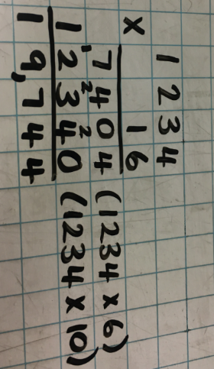
Division  Divide at least 3 digit numbers by 1 and 2 digit numbers  When working with decimals draw attention to the context of the calculation in terms of how they should be recorded. |  |  | Move into decimal places to divide the number accruately.  If the divisor is a 2 digit number then jot the multiples of that divisor down to help.
Doubling and Halving
Doubling  numbers to 10  Leading on from equal groups – children understand that doubling something means putting the same quantity out twice (two times) | Use a range of equipment and scaffolds.  Double 4 is 8  4 doubled is 8  4 put out twice is 8  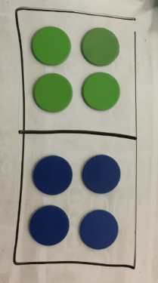  4 add another 4 is 8 |  | 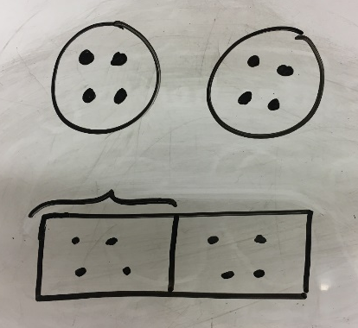  Represent the doubling pictorially |  | 4 + 4 = 8  4 x 2= 8  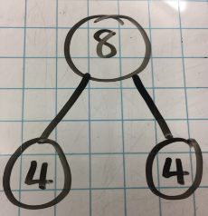
Halving even numbers to 20 | Sharing using a range of objects  8 shared between 2  Half of 8  8 halved |  | 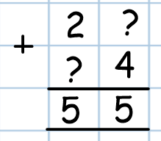  Represent the sharing pictorially |  | 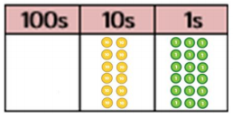  8 $÷$ 2 = 4
Doubling/halving  Using known facts - numbers within 100 | Model doubling/halving using diennes  If I know that double 4 is 8 I also know that double 40 is 80  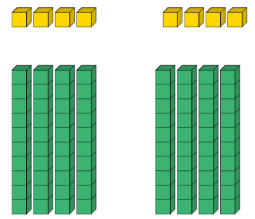  4 x 2 =8  40 x 2 = 80  80  8 ÷ 2 = 4  80 ÷ 2 = 40  If I know that half of 8 is 2, I also know that half of 80 is 40 |  | Representing doubling/halving pictorally  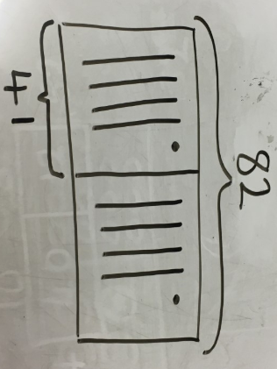 |  | starting to use partitioning - sticks and smiles  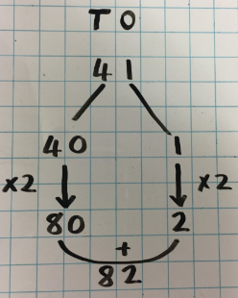  41 doubled = 82 82 halved = 41  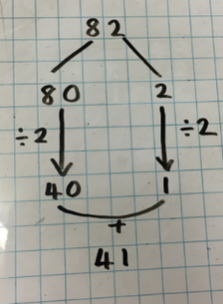  The smiles recombine the numbers to arrive at the quotient or product.
Doubling/halving numbers within 1,000  Numbers beyond 1,000 including numbers with decimal points | Doubling using place value counters  Double 643 = 643 x 2  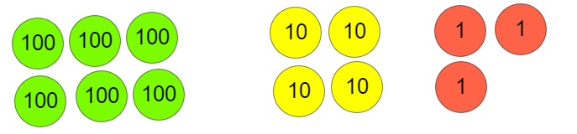  Putting the same quantity out twice  Half 1,286 = 1,286 ÷ 2  Use PVC to share into 2 equal groups |  |  |  | Partitioning with 3 digits  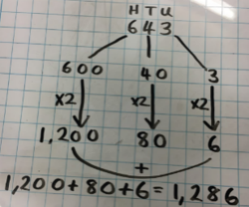  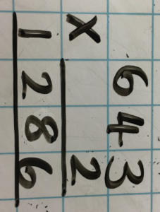  643 x 2 = double 643  Partitioning numbers with at least 4 digits  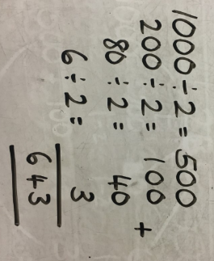  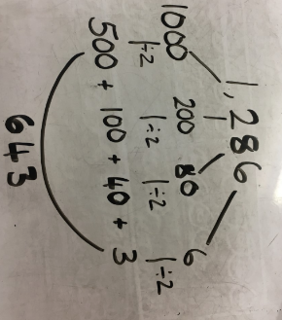
Conceptual variation for multiplication; different ways to ask children to solve 6 x 23
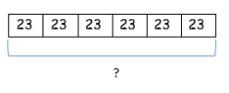 |  | Mai had to swim 23 lengths, 6 times a week.  How many lengths did she swim in one week.  With the place value counters, prove that 6 x 23 = 138 |  | Find the product of 6 and 23  6 x 23 =  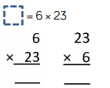 |  | What is the calculation?  What is the product?
Conceptual variation for division; different ways to ask children to solve 615 ÷ 5
Using the part whole model below, how can you divide 615 by 5 without using short division?  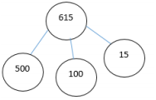 |  | I have £615 and share it equally between 5 bank accounts. How much will be in each bank account?  (sharing)  615 pupils need to be put into 5 groups. How many will be in each group?  (grouping) |  | 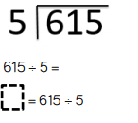 |  | 